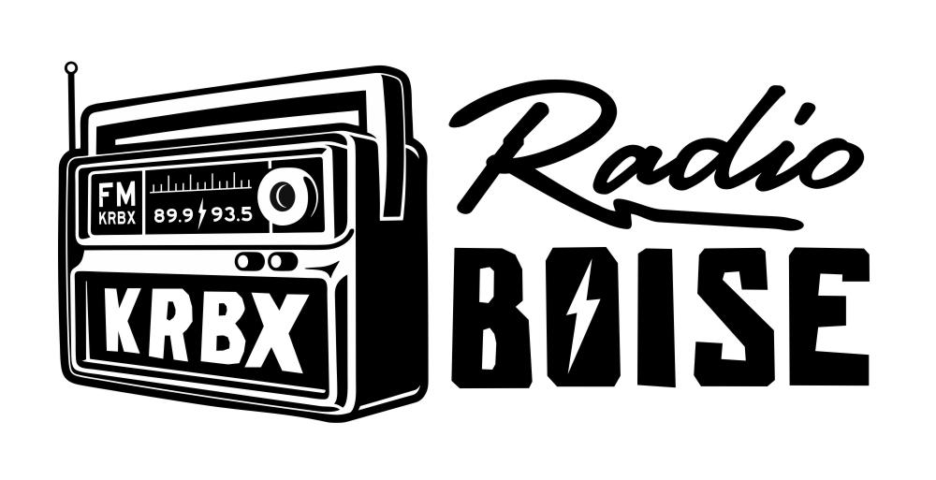

—- AGENDA —-

Radio Boise Board of Directors’ Meeting

Thursday, April 28, 2022

Location: The Alaska Center, Boise Idaho

6:00pm to 7:30 pm

Call to order - (Abrahamson)

Approval of minutes - 5 minutes - (Shirrod)

GM Update - 20 minutes - (Pearson)

Financial Report - 20 minutes - (Pearson, Callaway)

Internal Affairs Report - 10 minutes - (Abrahamson)

External Affairs Report - 15 minutes - (Winkle, Pearson, Tansey)

Public Comment

Adjournment - (Abrahamson)

