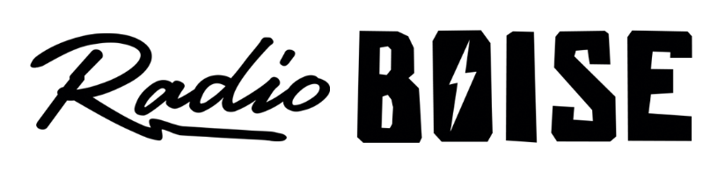
--Minutes--
Radio Boise Board of Directors (BoD) Meeting
Thursday, October 28, 2021 - -6:00 - 7:00 PM
Online via Zoom

BoD Members (9): Rachel Abrahamson (Chair), Daniel Glynn (Immediate Past Chair), Matt Hicks (Vice Chair), Meaghan Lopez (Secretary), Chelle Nystrom, Daniel Felkins, Dora Ramirez, Kendall Schreiner, Karen Callaway

BoD Members In Attendance (8): Abrahamson, Nystrom, Callaway, Hicks, Ramirez, Lopez, Felkins, Markley (GM)

Visitors:Dave Grabarczyk, Rebecca Shirrod, Matt Haga, Mike Markley

Agenda and minutes are posted online at:
http://radioboise.us/board-of-directors/agendas-and-meeting-notes/

Call to Order: 6:04 pm - Abrahamson
Move to Approve Minutes: September 30, 2021
Nystrom- Motion to approve
Abrahamson- Second
Motion carried
GM Update:
- Fundraising:
  - $65,000 raised during Radiothon
  - Successful increase in monthly givers
  - Data transfer for donors/HiFi/Radiothon info
- Financial:
  - Payroll tax update
  - Boise Arts and History grant update
- Staff:
  - Kettle of Fish and Femme Fatale moving times
  - New social media manager
  - Beth’s last week as interim GM

Financials:
- September Pending Adjustments
  - Lopez - Motion to approve
  - Hicks - Second
  - Motion carried
- Forgiven PPP loans needs to be moved to income, approval pending adjustment

Internal Affairs:
- Interviews for GM
- Leah’s contract for payroll:
  - Notice to end payroll duties on Nov. 1st, 2021
  - Rewrite contract
  - Meeting for Beth, Karen, and Leah to finalize before Beth leaves

Governance:

- Karen has accepted and been appointed to vacant position as Treasurer

External Affairs:

- Successful Radiothon!
- HiFi art:
  - Trade for printing 2020 art by PNYE auction
  - Call to artist for 2021, open through Nov.
  - Public voting open until PNYE auction
  - Expanding merch, stickers, prints
  - T-Shirts by Ashley Dreyfus

Public Comment: None

Adjourned: 6:55pm - Abrahamson

