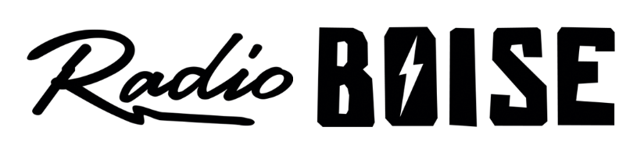
--Minutes--
Radio Boise Board of Directors (BoD) Meeting
Thursday, September 30, 2021 - -7:00 - 7:30 PM
Online via Zoom

BoD Members (9): Rachel Abrahamson (Chair), Daniel Glynn (Immediate Past Chair), Matt Hicks (Vice Chair), Meaghan Lopez (Secretary), Chelle Nystrom, Daniel Felkins, Dora Ramirez, Kendall Schreiner, Karen Callaway

BoD Members In Attendance (7): Abrahamson, Glynn, Nystrom, Ramirez, Lopez, Felkins, Markley (GM)

Visitors: Chris Tansey, Rebecca Shirrod, Matt Haga, Mike Markley, Robert Stevahn, Kristin Thomas

Agenda and minutes are posted online at:
http://radioboise.us/board-of-directors/agendas-and-meeting-notes/

Call to Order: 7:03 pm - Abrahamson
Move to Approve Minutes: August 26, 2021
Glynn- Motion to approve
Nystrom- Second
Motion carried
GM Update:
- Operations:
  - COVID protocols
  - Radiothon board volunteers Oct. 13-26
  - Translator replacement
  - Programming updates
- Financial:
  - Boise Arts and History grant, new sound equipment
  - Underwriting cash in
  - Treefort merch sales
  - Budget- PPP loan forgiveness and payroll tax credit
- Staff:
  - New social media manager

Financials:
- August financials
  - Lopez - Motion to approve
  - Felkins - Second
  - Motion carried
- Radiothon goal to bring back into budget
- Monthly gifts fixed

Internal Affairs:
- New GM hire candidates and interviews

External Affairs:

- Successful Treefort and merch sales
- Radiothon 10/13-26
- Board volunteers
- HiFi art
  - 2020 being printed
  - 2021 art open to local artists

Public Comment: None

Adjourned: 7:30pm

