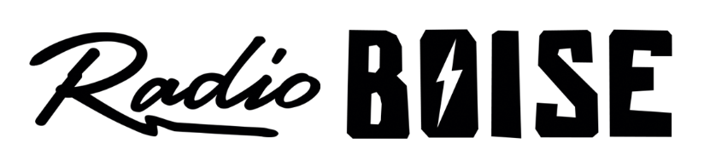
--Minutes--
Radio Boise Board of Directors (BoD) Meeting
Thursday, August 26, 2021 - - 6:00 - 6:22 PM
Online via Zoom

BoD Members (9): Rachel Abrahamson (Chair), Daniel Glynn (Immediate Past Chair), Matt Hicks (Vice Chair), Meaghan Lopez (Secretary), Chelle Nystrom, Daniel Felkins, Dora Ramirez, Kendall Schreiner, Karen Callaway

BoD Members In Attendance (10): Abrahamson, Glynn, Nystrom, Hicks, Ramirez, Lopez, Felkins, Callaway, Schreiner, Markley (GM)

Visitors: Wayne Birt, Dave Grabarczyk, Holly Johnson, Sarah Curtis, Christ Tansey, Unknown Number, Brian Allred, Doug McRoberts, Dave Manion, Rebecca Shirrod

Agenda and minutes are posted online at:
http://radioboise.us/board-of-directors/agendas-and-meeting-notes/

Call to Order: 6:02 pm - Abrahamson
Move to Approve Minutes: June 24, 2021
Hicks- Motion to approve
Abrahamson- Second
Motion carried
GM Update:
- Brian Allred: translator issues/broken and being repaired, receiver replacement
- Boise Arts & History Grant, PPP loans
- Station COVID protocols

Financials:
- June financials
  - Lopez - Motion to approve
  - Hicks - Second
  - Motion carried
- July financials
  - Lopez - Motion to approve
  - Hicks - second
  - Motion carries
- Underwriters, workers comp
- Over budget for June and July

Internal Affairs:
- New GM hire interviews amd update
- Karen Callaway introduced

Public Comment: None

Meetings will continue on Zoom
Adjourned: 6:22 pm

