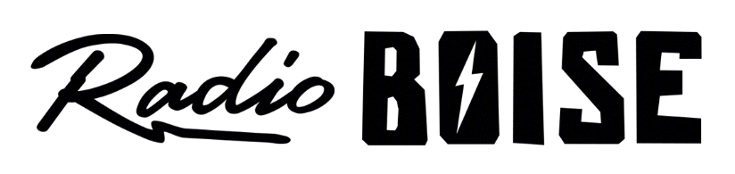
--AGENDA--
Radio Boise Board of Directors’ Meeting
Thursday, November 18, 2021
Location: via teleconference, see details below
6:00pm to 7:30pm

Agenda and minutes posted online at: https://radioboise.org/about-krbx/board-of-directors/agendas-and-meeting-notes/

- Approval of Minutes (5 minutes) (Lopez)
- Station Update (in lieu of GM Update, 10 minutes) (Abrahamson)
  - Programmer additions
- Approval of Financials (5 minutes) (Abrahamson)
- Internal Affairs Committee (10 minutes) (Hicks)
  - GM hire update
  - Migration costs for transfer to Little Green Light
  - 990
- Governance (5 minutes) (Abrahamson)
  - Board applications
- External Affairs Committee (10 minutes) (Abrahamson)
  - Radiothon wrap up numbers and pick up party update
  - PNYE information and silent auction
  - HiFi Open Call to Artists
- Public Comment

Upcoming Board Events
Next Board Meeting, Thursday, December 16, 2021, 6:00pm – 7:30 pm, Location: via teleconference

Members of the public who wish to attend this meeting can email info@radioboise.org for the Zoom meeting information.

