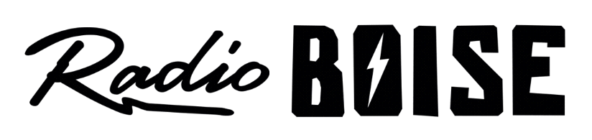
--AGENDA--
Radio Boise Board of Directors’ Meeting
Thursday, September 30, 2021
Location: via teleconference, see details below
7:00pm to 8:00pm

Agenda and minutes posted online at: https://radioboise.org/about-krbx/board-of-directors/agendas-and-meeting-notes/

- Approval of Minutes (5 minutes) (Lopez)
- GM Update (10 minutes) (Markley)
- August Financials (10 minutes) (Markley)
- Internal Affairs Committee (10 minutes) (Abrahamson)
  - GM hire update
- External Affairs Committee (10 minutes) (Abrahamson)
  - Radiothon
  - HiFi art
- Public Comment

Upcoming Board Events
Next Board Meeting, Thursday, October 28, 6:00pm – 7:30 pm, Location: via teleconference

Members of the public who wish to attend this meeting can email info@radioboise.org for the Zoom meeting information.

