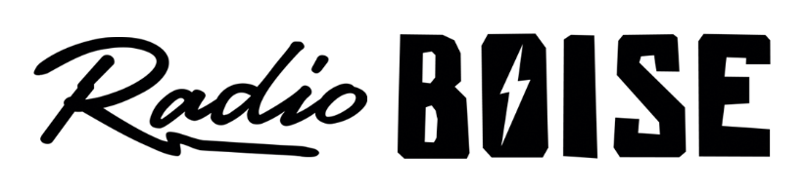
--Minutes--
Radio Boise Board of Directors (BoD) Meeting
Thursday, June 24, 2021 - - 6:00 - 7:09 PM
Online via Zoom

BoD Members (8): Rachel Abrahamson (Chair), Daniel Glynn (Immediate Past Chair), Matt Hicks (Vice Chair), Meaghan Lopez (Secretary), Chelle Nystrom, Daniel Felkins, Dora Ramirez, Kendall Schreiner

BoD Members In Attendance (6): Abrahamson, Glynn, Nystrom, Hicks, Ramirez, Lopez

Visitors: Wayne Birt, Greg Harness, Sally Kane, Wendy Fox, Holly Johnson, Kristin Thomas, Karen Callaway, Sarah Curtis, Christ Tansey, Unknown Number, Daphne Stanford

Agenda and minutes are posted online at:
http://radioboise.us/board-of-directors/agendas-and-meeting-notes/

Call to Order: 6:05 - Abrahamson
Move to Approve Minutes: May 27, 2021
Lopez- Motion to approve
Abrahamson- Second
Motion carried
Chair Comments: (Abrahamson)
- Responsibility of members
- Maintain respectful conduct between members
- Retreat information and details and NFCB representation
Staff Comments: (Birt)
- Strategic planning and framework
- SWOT analysis

Internal Affairs, Financials:
- May financials
  - Lopez - Motion to approve
  - Glynn - Second
  - Motion carried
- NFCB conferences and assessments for retreat

Governance:
- Karen Callaway recommendation
- Treasurer/External Affairs chair by retreat

Public Comment:
- Holly Johnson: Does board agreement apply to social media?
  - Sally: Organization creates policy that spells things out
  - Dan: Being cognizant right now, resolution if needed
- Greg Harness: Appreciate openness and talking through issues civilly, thank you.

Adjournment:
- Glynn - motion to close meeting
- Abrahamson - second
- Motion carried, meeting adjourned at 7:09 pm
Break Out Session:
- Glynn - motion to approve Karen Callaway
- Lopez - second
- Motion carried unanimously
- Adjourned at 7:13 pm

