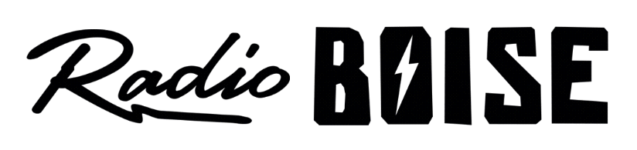
--AGENDA--
Radio Boise Board of Directors’ Meeting
Thursday, August 26, 2021
Location: via teleconference, see details below
6:00pm to 7:30pm

Agenda and minutes posted online at: https://radioboise.org/about-krbx/board-of-directors/agendas-and-meeting-notes/

- Approval of Minutes (5 minutes) (Lopez)
- GM Update (Markley)
- Internal Affairs Committee Report
  - June and July Financials (15 minutes) (Nystrom)
  - New GM hire (10 minutes) (Abrahamson)
- Public Comments
- Board Break Out Session Training (closed to public)

Upcoming Board Events
Next Board Meeting, Thursday, September 23, 6:00pm – 7:30 pm, Location: via teleconference

Members of the public who wish to attend this meeting can email info@radioboise.org for the Zoom meeting information.

