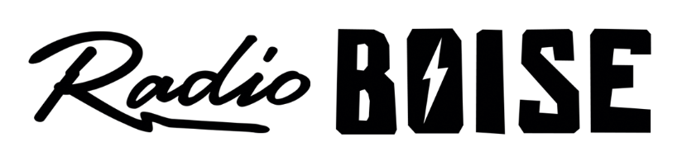
--Minutes--
Radio Boise Board of Directors (BoD) Meeting
Thursday, May 27, 2021 - - 6:00 - 7:40 PM
Online via Zoom

BoD Members (13): Rachel Abrahamson (Chair), Daniel Glynn (Immediate Past Chair), Matt Hicks (Vice Chair), Dave Foster (Treasurer), Meaghan Lopez (Secretary), Chelle Nystrom, Jason Pretty Boy, Daniel Felkins, Dora Ramirez, Cole Calvin, Jessica Harned, Austin Foudy, Kendall Schreiner.

BoD Members In Attendance (unknown): Abrahamson, Glynn, Calvin, Foster, Nystrom, Felkins, Pretty Boy, and Beth Markley (General Manager), complete list unknown.

Visitors: Visitor list unknown

Agenda and minutes are posted online at:
http://radioboise.us/board-of-directors/agendas-and-meeting-notes/

Call to Order: 6:10 - Abrahamson
Move to Approve Minutes: April 22, 2021
Foster- Motion to approve
Abrahamson- Second
Motion carried
GM Update:
- Discussed COVID protocols regarding guests
- Connecting with staff
- Hire and onboard

Internal Affairs, Financials:
- April financials
  - Felkins - Motion to approve
  - Nystrom - Second
  - Motion carried

Governance:
- GM job description
  - Motion to approve - Abrahamson
  - Second - Calvin
  - Empowering committee to finalize draft posted and post position by June 1 for a period of 4 weeks ending June 30

Adjournment: Abrahamson adjourned the meeting at 7:40 pm

