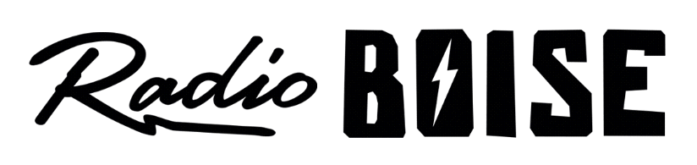
--AGENDA--
Radio Boise Board of Directors’ Meeting
Thursday, June 24, 2021
Location: via teleconference, see details below
6:00pm to 7:30pm

Agenda and minutes posted online at: https://radioboise.org/about-krbx/board-of-directors/agendas-and-meeting-notes/

- Approval of Minutes (5 minutes) (Lopez)
- Chair Comment (10 minutes) (Abrahamson)
- Staff Comment (15 minutes) (Birt)
- Internal Affairs Committee Report
  - May Financials (15 minutes) (Nystrom)
  - Board Retreat (10 minutes) (Abrahamson)
    - Conference
    - Assessments
- Governance Committee Report (Abrahamson)
  - New Board Members
  - Treasurer
  - External Affairs Chair
- Public Comments

Upcoming Board Events
Next Board Meeting, Thursday, August 26, 6:00pm – 7:30 pm, Location: via teleconference

Members of the public who wish to attend this meeting can email info@radioboise.org for the Zoom meeting information.

