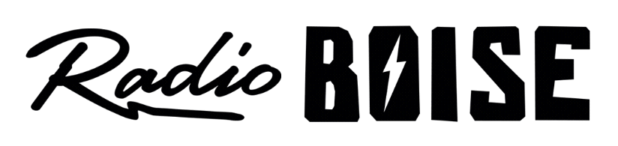
--AGENDA--
Radio Boise Board of Directors’ Meeting
Thursday, May 27, 2021
Location: via teleconference, see details below
6:00pm to 7:30pm

Agenda and minutes posted online at: https://radioboise.org/about-krbx/board-of-directors/agendas-and-meeting-notes/

- Approval of Minutes (5 minutes) (Lopez)
- GM Update (10 minutes) (Markley)
- Internal Affairs Committee Report
  - Reading Financial Reports (10 minutes) (Nystrom)
  - April Financials (10 minutes) (Foster)
  - Board Retreat (5 minutes) (Abrahamson)
- GM Recruitment (10 minutes) (Abrahamson)
  - Job Description
  - Target Dates
  - Job Listing
- External Affairs Committee Report (20 minutes) (Markley)
  - First Thursday
  - Premium Pick Up Party
  - Annex Plan
  - MOE
  - Commemorative beer label with Woodland Empire
  - Board thank-a-thon
- Public Comments

Upcoming Board Events
Next Board Meeting, Thursday, June 24, 6:00pm – 7:30 pm, Location: via teleconference

Members of the public who wish to attend this meeting can email info@radioboise.org for the Zoom meeting information.

