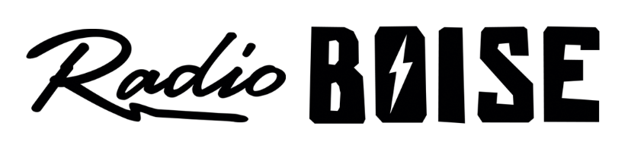
--Minutes--
Radio Boise Board of Directors (BoD) Meeting
Thursday, March 25, 2021 - - 6:00 - 8:00 PM
Online via Zoom

BoD Members (14): Rachel Abrahamson (Chair), Daniel Glynn (Immediate Past Chair), Matt Hicks (Vice Chair), Dave Foster (Treasurer), Meaghan Lopez (Secretary), Chelle Nystrom, Kristen Cheyney, Jason Pretty Boy, Daniel Felkins, Dora Ramirez, Cole Calvin, Jessica Harned, Austin Foudy, Kendall Schreiner.

BoD Members In Attendance (12): Abrahamson, Cheyney, Foudy, Glynn, Calvin, Foster, Harned, Lopez, Nystrom, Ramirez, Felkins, Pretty Boy, and Beth Markley (General Manager).

BoD Members Unable to Attend (3): Schreiner, Hicks

Staff: Wayne Birt, Chris Tansey, Jan Lindner, Nichole Albertson
Visitors: Wendy Fox, Grant Olsen, Colby Spath, Brett Netson, Robert Stevahn, Mike Markley, Holly Johnson, Ben Kline, Lila Eidi, Kristin Thomas, Jason, Thomas Paul, Anonymous Number

Agenda and minutes are posted online at:
http://radioboise.us/board-of-directors/agendas-and-meeting-notes/

Call to Order: 6:06 - Abrahamson
Move to Approve Minutes: February 25, 2021
Cheyney - Motion to approve
Glynn - Second
Motion carried
GM Update:
- Discussed anniversary fundraising
- Discussed payroll and PPP loans
- 2021 budget and staff updates
- Discussed underwriting needs
- Discussed programmers meeting feedback
- Discussed Patagonia grant

Internal Affairs, Financials:
- January and February financials
  - Lopez - Motion to approve
  - Felkins - Second
  - Motion carried
- Discussed tower lease agreement execution and rent

External Affairs:

- Discussed Radiothon and Anniversary video
- Discussed cleaning/COVID supply donation needs
- Discussed Woodland Empire custom beer can for anniversary fundraiser
- Discussed anniversary fund and release date

Governance:
- Discussed board retreat and training, July
- Discussed possible new position

Boise Arts, Culture, and History Anti-Racism Coalition:

- Discussed responsibilities and recent events
- Community Advisory Board permanent item

Public Comment:
- Kristen: new GM search and committee, on boarding and culture preservation, ethical protocol concerns, clarification that she did not resign
- Robert: restructuring is positive, suggested programmers association, concerns about volunteer hours and labor costs, work/life balance for paid staff, anti-racist committee
- Wendy: appreciation of board members
- Brett: Radiothon, wants to be heard, concerns about tone deaf press release and discrepancies, concerns about disconnect between board and programmers, emphasized that Radio Boise is a team effort and no one owns the station
- Wayne: meeting was encouraging, emphasized need to listen to each other
Adjournment: Abrahamson adjourned the meeting at 7:57 pm

