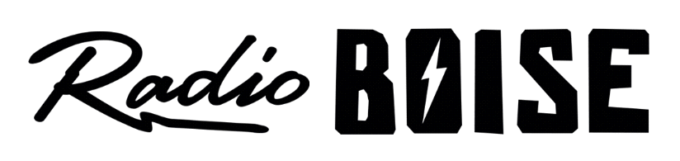
--AGENDA--
Radio Boise Board of Directors’ Meeting
Thursday, April 22, 2021
Location: via teleconference, see details below
6:00pm to 7:30pm

Agenda and minutes posted online at: https://radioboise.org/about-krbx/board-of-directors/agendas-and-meeting-notes/

- Approval of Minutes (5 minutes) (Lopez)
- Staff Presentation: Jennifer Jerrett (10 minutes)
- GM Update (15 minutes) (Markley)
- Radiothon Update
- Internal Affairs Committee Report (15 minutes) (Markley)
- March Financials
- External Affairs Committee Report (10 minutes) (Abrahamson)
- Board Radiothon Engagement
- Board Chair Business (15 minutes) (Abrahamson)
- GM Committee Announcement
- Public Comments

Upcoming Board Events
Next Board Meeting, Thursday, May 27, 6:00pm – 7:30 pm, Location: via teleconference

Members of the public who wish to attend this meeting can email info@radioboise.org for the Zoom meeting information.

