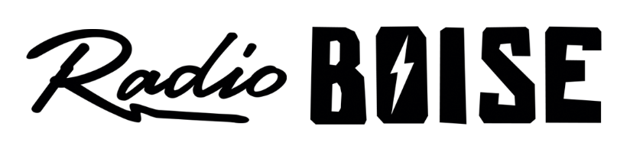
--Minutes--
Radio Boise Board of Directors (BoD) Meeting
Thursday, February 25, 2021 - - 6:00 - 7:30PM
Online via Zoom

BoD Members (15): Rachel Abrahamson (Chair), Daniel Glynn (Immediate Past Chair), Matt Hicks (Vice Chair), Dave Foster (Treasurer), Meaghan Lopez (Secretary), Chelle Nystrom, Kristen Cheyney, Jason Pretty Boy, Daniel Felkins, Beth Markley, Dora Ramirez, Cole Calvin, Jessica Harned, Austin Foudy, Kendall Schreiner.

BoD Members In Attendance (13): Abrahamson, Cheyney, Foudy, Glynn, Calvin, Foster, Harned, Hicks, Lopez, Markley, Nystrom, Ramirez and Jessica Evett (General Manager).

BoD Members Unable to Attend (3): Felkins, Pretty Boy, Schreiner

Staff: None
Visitors: None

Agenda and minutes are posted online at:
http://radioboise.us/board-of-directors/agendas-and-meeting-notes/

Call to Order: 6:09 - Abrahamson
Move to Approve Minutes: January 28, 2021
Foster - Motion to approve
Lopez - Second
Motion carried
GM Update:
- Discussed interview and hiring of CPA contractor
- Discussed staff job descriptions and updates
- 2021 budget
  - Cheyney - Motion to approve with addendum to fix formula
  - Foster - Second
  - Motion carried
- Discussed underwriting

Internal Affairs, Financials:
- November and December financials
  - Abrahamson - Motion to approve
  - Glynn - Second
  - Motion carried
- Discussed accounts receivable
- Discussed EIDL (SBA) loan and PPP
- Discussed City of Boise SBA CARES Act eligibility
- Discussed tower lease agreement
  - Cheyney - Motion to approve lease
  - Lopez - Second
  - Motion carried

Governance:
- Discussed board engagement and subcommittees
- Discussed new positions opening and new members
- Goodbye to Beth Markley, terming out as board member

Public Comment: n/a
Adjournment: Abrahamson adjourned the meeting at 7:37 pm
Executive Session: Abrahamson called executive session to order at 7:38 pm and adjourned the executive session at 8:39 pm

