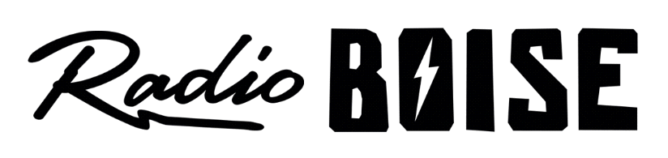
--AGENDA--
Radio Boise Board of Directors’ Meeting
Thursday, March 25, 2021
Location: via teleconference, see details below
6:00pm to 7:20pm

Agenda and minutes posted online at: https://radioboise.org/about-krbx/board-of-directors/agendas-and-meeting-notes/

- Approval of Minutes (5 minutes) (Lopez)
- GM Update (10 minutes) (Markley)
- HR
- Internal Affairs Committee Report (15 minutes) (Markley/Hicks)
- January & February Financials
- Tower Lease
- PPP
- External Affairs Committee Report (15 minutes) (Abrahamson)
- Radioathon & Anniversary doc
- Cleaning/COVID donations
- Woodland Empire
- Governance Committee Report (10 minutes) (Abrahamson)
- July Board Retreat
- New Member
- Boise Arts, Culture, and History Anti-Racism Coalition (15) (Abrahamson)
- Public Comments

Upcoming Board Events
Next Board Meeting, Thursday, April 22, 6:00pm – 7:30 pm, Location: via teleconference

Members of the public who wish to attend this meeting can email info@radioboise.org for the Zoom meeting information.

