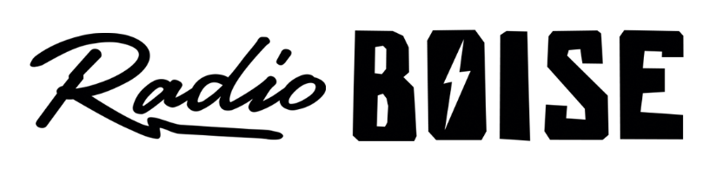
--Minutes--
Radio Boise Board of Directors (BoD) Meeting
Thursday, November 19th, 2020 - - 6:00 - 7:30PM
Online via Zoom

BoD Members (13): Daniel Glynn (Chair) Kristen Cheyney (Immediate Past Chair), Chelle Nystrom (Treasurer), Dave Foster (Vice Chair, Secretary), Jason Pretty Boy, Daniel Felkins, Matt Hicks, Beth Markley, Rachel Abrahamson, Dora Ramirez, Cole Calvin, Meaghan Lopez, Jessica Harned.

BoD Members In Attendance (11): Abrahamson, Cheyney, Felkins, Foster, Harned, Hicks, Lopez, Markley, Nystrom, Pretty Boy, Ramirez and Jessica Evett (General Manager).

BoD Members Unable to Attend (2) : Calvin, Glynn

Staff: None
Visitors: None

Agenda and minutes are posted online at:
http://radioboise.us/board-of-directors/agendas-and-meeting-notes/

Call to Order: 6:09 - Foster
Move to Approve Minutes: October 29, 2020
Markley - Motion to approve
Abrahamson - Second
Motion carries
GM Update:
- Discussed diversity, equity and inclusion activities in Boise and with the National Federation of Community Broadcasters

External Affairs
- Discussed Practice New Year's Eve plan
- Explored how listeners can give cash donations in addition to the auction

Internal Affairs, Financials:
- Reviewed September financials
  - Felkins - Motion to approve
  - Abrahamson – Second
  - Motion carried
- October financials are looking good but not completed because of the volume of donation transactions
- Reviewed the 990
  - Pretty Boy – Motion to ratify
  - Felkins Second
  - Motion carried
Governance:
- Reviewed board matrix
- Voted on new directors
Kendall Schreiner
Austin Foudy
Unanimously approved 9 votes
Public Comment: n/a
Adjournment: Foster adjourned the meeting at 7:12 PM.

