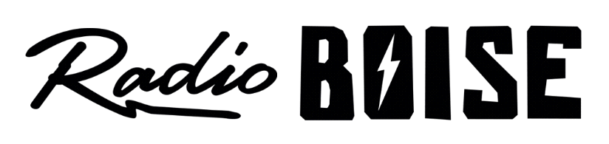
--AGENDA--
Radio Boise Board of Directors’ Meeting
Thursday, February 25, 2021
Location: via teleconference, see details below
6:00pm to 7:35pm

Agenda and minutes posted online at: https://radioboise.org/about-krbx/board-of-directors/agendas-and-meeting-notes/

- Approval of Minutes (5 minutes) (Lopez)
- GM Update (10 minutes) (Evett)
- New Employee and Contractor
- 2021 Budget (15 minutes) (Evett)
- Internal Affairs Committee Report (15 minutes) (Nystrom)
- November & December Financials
- External Affairs Committee Report (10 minutes) (Evett)
- Lease Discussion (10 minutes) (Hicks)
- Governance Committee Report (10 minutes) (Abrahamson)
- New Members
- Board Member Recognition (5 minutes) (Lopez)
- Public Comments
- Executive Session GM Performance Review Discussion (15 minutes) (Abrahamson)

Get together for Beth Markley, March 2, 5:00pm - 9:00pm, Location: Ochos Wine Bar

Upcoming Board Events
Next Board Meeting, Thursday, February 25, 6:00pm – 7:30 pm, Location: via teleconference

Members of the public who wish to attend this meeting can email info@radioboise.org for the Zoom meeting information.

