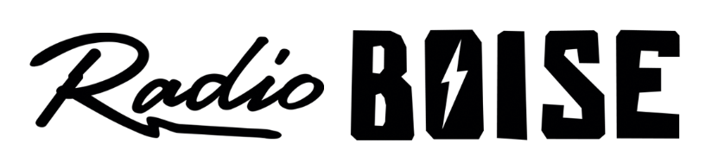
--Minutes--
Radio Boise Board of Directors (BoD) Meeting
Thursday, October 29th, 2020 - - 6:00 - 7:30PM
Online via Zoom

BoD Members (13): Daniel Glynn (Chair) Kristen Cheyney (Immediate Past Chair), Chelle Nystrom (Treasurer), Dave Foster (Vice Chair), Jason Pretty Boy (Secretary), Daniel Felkins, Matt Hicks, Beth Markley, Rachel Abrahamson, Dora Ramirez, Cole Calvin, Meaghan Lopez, Jessica Harned.

BoD Members In Attendance (11): Abrahamson, Calvin, Cheyney, Felkins, Foster, Harned, Hicks, Lopez, Markley, Pretty Boy, Ramirez and Jessica Evett (General Manager).

BoD Members Unable to Attend (2) : Glynn, Nystrom

Staff: None
Visitors: None

Agenda and minutes are posted online at:
http://radioboise.us/board-of-directors/agendas-and-meeting-notes/

Call to Order: 6:10 - Foster
Move to Approve Minutes: September 24, 2020
Abrahamson - Motion to approve after fixing date typo
Cheyney - Second
Motion carries
GM Update:
- Discussed Radiothon record donations $64,719.
- Working on a draft budget, plan on approval December 17th

Internal Affairs, Financials:
- September financials looking good. Not finalized yet. As noted earlier, Radiothon financials looks good.
- Hicks described the lease terms that were presented to us by our tower landlord.
We have until August 2021 on the current term of the lease.
The landlord moved our antenna to a lower location than it should have been.
FCC attorney was consulted.
The Bureau of Land Management may have some input into this issue.

External Affairs
- Cheney presented on the importance of obtaining donations for online auction items.

Governance:
- Discussed candidates for board of directors.
Kendall Shreiner
Austin Foudy
Public Comment: Discussed Zoom security changes to allow safe public attendance
Additional Comments: Discussed community election safety
Adjournment: Foster adjourned the meeting at 7:24 PM.

