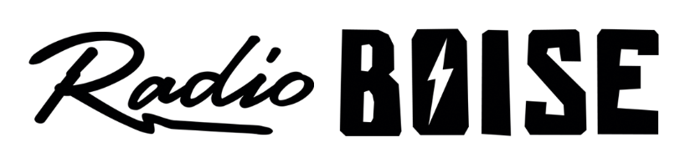
--Minutes--
Radio Boise Board of Directors (BoD) Meeting
Thursday, April 30, 2020 6:00 - 7:00PM
Online teleconference

BoD Members (9): Daniel Glynn (Chair) Kristen Cheyney (Immediate Past Chair), Chelle Nystrom (Treasurer), Dave Foster (Vice Chair), Jason Pretty Boy (Secretary), Daniel Felkins, Matt Hicks, Beth Markley, Rachel Abrahamson.

BoD Members In Attendance (9): Abrahamson, Felkins, Foster, Glynn, Hicks, Markley, Nystrom, Pretty Boy and Jessica Evett (General Manager).

BoD Members Unable to Attend (1): Cheyney

Staff: None

Agenda and minutes are posted online at:
http://radioboise.us/board-of-directors/agendas-and-meeting-notes/

Call to Order: 6:09PM - Glynn
Move to Approve Minutes: April 2, 2020
Nystrom - Motion to approve
Hicks - Second
Pass
GM Update:
- Latino Card produced at Radio Boise won a programming award from the Idaho Press Club
- Discussed pledge drive activity and positive feedback so far and how we are on an encouraging track for a $50k goal for the spring
- Reviewed long term plans for opening up to allow more people in the studio
- Prompted the internal affairs committee to meet before the next financial review

PPP, CARES, Financial Relief:
- Fortunately, we were approved for $33k in PPP through First Interstate Bank
- EIDL loan application is under consideration for disaster relief but not sure of likelihood
- Idaho Humanities Council is reaching out to solicit grant applicants
- Idaho Commission on the Arts providing funding
- Corporation for Public Broadcasting possibility for 2021 funding
- Other non-profit support groups are sending recommendations our way
- Jess is continuing to pursue exploration of loans and grants

COVID-19:
- Our response is going well

Budget:
- Reviewed Contingency Budget
- Some income is projected to decrease, particularly events related
- Expenses also down for events
- Need to watch receivables closely

Committees:
- Set times for Internal and External affairs committees.

Public Comment: None
Adjournment: Glynn adjourned the meeting at 7:26 PM.

