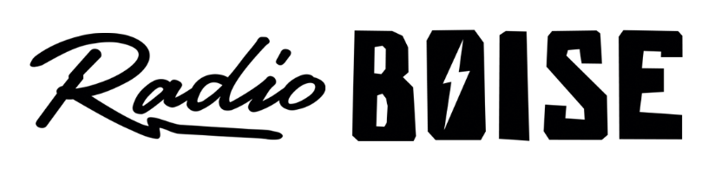
--Minutes--
Radio Boise Board of Directors (BoD) Meeting
Thursday, April 2, 2020 6:00 - 7:00PM
Online teleconference

BoD Members (9): Daniel Glynn (Chair) Kristen Cheyney (Immediate Past Chair), Chelle Nystrom (Treasurer), Dave Foster (Vice Chair), Jason Pretty Boy (Secretary), Daniel Felkins, Matt Hicks, Beth Markley, Rachel Abrahamson.

BoD Members In Attendance (9): Abrahamson, Cheyney, Foster, Glynn, Hicks, Markley, Nystrom, Pretty Boy and Jessica Evett (General Manager).

BoD Members Unable to Attend (1):, Felkins

Staff: None

Agenda and minutes are posted online at:
http://radioboise.us/board-of-directors/agendas-and-meeting-notes/

Call to Order: 6:05PM - Glynn
Move to Approve Minutes: February 27, 2020
Foster - Motion to approve
Nystrom - Second
Pass
GM Update:
Working on SBA loans.
- Board voted via Slack to approve applying for SBA loans.
- SBA 7 Loan for disaster relief.
- PPP for payroll protection.
Discussed income and expense issues.
- Expense challenges in March due to cancelled raffle and no merch sales
- Revenue also down due to cancelled events related to Treefort and raffle
- Pledge drive will be impacted by low challenge gifts
- Spring Fund Drive
- Defer expenses as much as possible and as appropriate
- Looking for underwriting leads

COVID-19:
- Practicing social distancing and sanitizing
- 70% of programmers producing remote material, shooting for 100% at home production
- People who are feeling sick are asked to stay home
Public Comment: None
Adjournment: Glynn adjourned the meeting at 7:08 PM.

