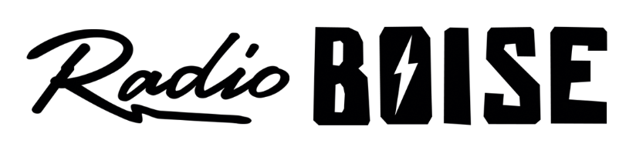
--Minutes--
Radio Boise Board of Directors (BoD) Meeting
Thursday, September 24th, 2020 - - 6:00 - 7:30PM
Online via Zoom

BoD Members (9): Daniel Glynn (Chair) Kristen Cheyney (Immediate Past Chair), Chelle Nystrom (Treasurer), Dave Foster (Vice Chair), Jason Pretty Boy (Secretary), Daniel Felkins, Matt Hicks, Beth Markley, Rachel Abrahamson.

BoD Members In Attendance (8): Abrahamson, Cheyney, Felkins, Foster, Glynn, Pretty Boy, Markley, Nystrom and Jessica Evett (General Manager).

BoD Members Unable to Attend (1) : Hicks

Staff: None
Visitors: None

Agenda and minutes are posted online at:
http://radioboise.us/board-of-directors/agendas-and-meeting-notes/

Call to Order: 6:13 - Glynn
Move to Approve Minutes: August 27, 2020
Glynn - Motion to approve
Foster - Second
Motion carries
GM Update:
- “Mission Moment” - How much listeners have missed the archiver since Radio Free America shutdown.
- Conversation around NFCB’s DEI toolkit.
- Underwriting Update including City of Boise pre-paying for James Castle House package.
- Programming Update, school programs, Radiothon plans, new archiver, tower lease, anti-racism coalition.
Internal Affairs, Financials:
August Financials
Foster - Motion to approve
Glynn – second
Motion carries

Economic Injury Disaster Loan policy approval
Cheney - Motion to approve
Foster – second
Motion carries
Governance:
Voted on candidates for board of directors.
Dora Ramirez
Cole Calvin
Meaghan Lopez
Jessica Harned
All unanimously approved.
Public Comment: None
Adjournment: Glynn adjourned the meeting at 7:30 PM.

