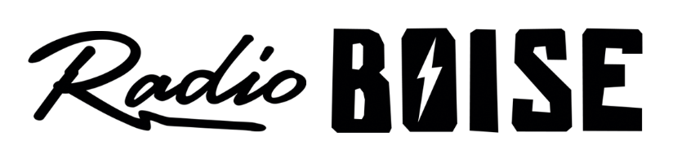
--Minutes--
Radio Boise Board of Directors (BoD) Meeting
Thursday, January 23rd, 2020 - - 6:00 - 7:30PM
Alaska Building – Radio Boise “Backstage” - 1020 Main St, Boise ID

BoD Members (7): Daniel Glynn (Chair) Kristen Cheyney (Immediate Past Chair), Chelle Nystrom (Treasurer), Dave Foster (Vice Chair), Jason Pretty Boy (Secretary), Daniel Felkins, Matt Hicks, Beth Markley.

BoD Members In Attendance (6): Cheyney, Felkins, Foster, Hicks, Nystrom, and Jessica Evett (General Manager).

BoD Members Unable to Attend (5):, Glynn, Markley, Pretty Boy.

Staff: None
Visitors: Rachel Abrahamson

Agenda and minutes are posted online at:
http://radioboise.us/board-of-directors/agendas-and-meeting-notes/

Call to Order: 6:05 - Cheyney
Move to Approve Minutes: December 19, 2019
Cheyney - Motion to approve
Foster - Second
Pass
GM Update:
- Discussed couch surfer event model and attendee data.
- Volunteer orientation first Thursday, starting in February.
- Examined possibilities for backfilling the part time volunteer and events coordinator position or contracting with a fundraising event planner.
- Explored options for program coordination to fulfill Patagonia grant requirements.
- Birds of Prey podcast will launch soon. Good example of collaboration between Radio Boise and independent producers.
- Valentines event ready to go.
- Discussed long term transmitter movement possibility.

Financial Update:
Reviewed November Financials
- Looked at income issues
Cheyney - Motion to approve November financials
Hicks - 2nd
Passed

Budget:
Reviewed 2020 Budget Proposal
- Radiothon and Individual Transactional gifts are the main increases in target amounts in Donations.
- Event income will be another big focus.
- Expenses increases of note include marketing management to ensure success with recruiting participants to grant funded programs.
- Discussed some further questions to clarify with staff before we can vote on approval via Slack

Public Comment: None
Board Election
Voted for Rachel Abrahamson for admission to the Board of Directors
Unanimous approval

Adjournment: Programmers Meeting is an important to attend event. February 20. The next meeting will be held on Thursday, February 27th, 2020 at 6PM in the KRBX Backstage (basement adjacent to studio). There being no further business, Cheyney adjourned the meeting at 7:40 PM.

