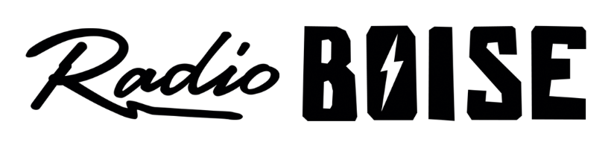
--Minutes--
Radio Boise Board of Directors (BoD) Meeting
Thursday, December 19th, 2019 - - 6:00 - 7:30PM
Alaska Building – Radio Boise “Backstage” - 1020 Main St, Boise ID

BoD Members (9): Kristen Cheyney (Chair), Chelle Nystrom (Treasurer), James Lineberger (Secretary), Dave Foster (Immediate Past Chair, Vice Chair), Alex Davis, Daniel Felkins, Matt Hicks, Beth Markley, Jason Pretty Boy.

BoD Members In Attendance (6): Cheyney, Foster, Glynn, Nystrom, Felkins and Jessica Evett (General Manager).

BoD Members Unable to Attend (5): Davis, Hicks, Lineberger, Markley, Pretty Boy.

Staff: None
Visitors: None

Agenda and minutes are posted online at:
http://radioboise.us/board-of-directors/agendas-and-meeting-notes/

Call to Order: 6:20 - Cheyney
Move to Approve Minutes: October 24, 2019
Request to correct attendance information- Glynn
-Foster offers changes
Glynn - Motion to approve with changes.
Nystrom - Second
Pass
GM Update: Referred to update on Slack
Nomination and Election of Officers for 2020:
Foster announced the Executive Committee’s slate of officer nominees:
Glynn – Chair
Foster – Vice-Chair
Nystrom – Treasurer
Pretty Boy – Secretary
Nystrom - Motion to approve.
Cheyney - Second
All in favor of the slate
Committee Structure:
- Brief discussion on 2020 committee structure to be continued Jan 2020:
  - Internal
  - External
  - Development
Financial Update:
Reviewed October Financials
- Had to return a grant for a project we were not able to deliver on beyond our control.
- Haven't had a good track record with events income and expenses.
- In the black for October mostly due to Radiothon.
- Need to improve accounts receivable.

Cheyney - Motion to approve October financials.
Glynn – Second
Pass

Budget:
Reviewed 2020 Budget Proposal
- Discussed the fact that the car raffle doesn't seem to do for us what we would like it to do for cash flow improvement in the summer months.
- Discussed new options for funding, events in the Backstage, Blues Cruise, Winery Music Tour, etc.

Public Comment: None
Adjournment: The next meeting will be held on Thursday, January 23rd, 2020 at 6PM in the KRBX Backstage (basement adjacent to studio). There being no further business, Cheyney adjourned the meeting at 7:30 PM.

