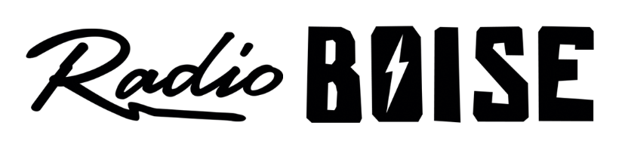
--Minutes--
Radio Boise Board of Directors (BoD) Meeting
Thursday, October 24th, 2019 - - 6:00 - 7:30PM
Alaska Building – 2nd Floor Conference Room - 1020 Main St, Boise ID

BoD Members (12): Kristen Cheyney (Chair), Chelle Nystrom (Treasurer), James Lineberger (Secretary), Dave Foster (Immediate Past Chair), Alex Davis, Daniel Felkins, Matt Hicks, Beth Markley, Jason Pretty Boy .

BoD Members In Attendance (7): Foster, Hicks, Pretty Boy, Markley, Davis and Jessica Evett (General Manager).

BoD Members Unable to Attend (4) : Lineberger, Nystrom, Cheyney, Glynn, Felkins

Staff: None
Visitors: None

Agenda and minutes are posted online at:
http://radioboise.us/board-of-directors/agendas-and-meeting-notes/

Call to Order: 6:12 - Foster

Move to Approve Minutes: September 28, 2019
Questions on wording around lease- Davis
-Foster offers changes
Hicks- Motion to approve with changes.
Markley- second
Pass

GM Update: Talk around “Mission Moment”. What we are doing to meet our overall mission?
- Conversation around Father’s Day Car Show- taking a long time to get money...only $4,200 collected.
- Sponsorship talk around E-Car and car show, making it a mission point that we are connected to promotion of alternative transportation.

- Conversation around Food for Thought- what are the takeaways versus other stations and here at Radio Boise.
- Events: PNYE will be December 6th at Gem State Events Center. Need donations for auctions contact Debra. Sustainability Fair/Fright Night Silent Disco (at JUMP) in Nampa on Oct. 26th. Thoughts on auction for PNYE, need to get it done quicker, more items. Talk about how it was better to have the auction close at event...anticlimactic last year. Moving forward might do a combo of online and in person.
- Radiothon: Started like a heart attack ended really good. Got past budget expectations but short of stretch goal. News cycle might have played a part in lower turnout at beginning of -thon.

Board Development:
- Foster- Don’t generally put out call for board members, generally happens via networking. Board Questions being looked at, maybe something to change.
- Davis- thought on lead generation, having a party to bring in future board members in conjunction with PYNE, invite past board members to create a bridge.
- Potential CAB- Nathaniel Hoffman, Scot Oliver, Dave ?.
- Pretty Boy- Is there a way to jump people straight to the board?
- Talk about bringing potential board members to meet and greet.

2020 Officers- Voting on officers on December 12th. Still need potential Vice Chair.

Strategic Planning:
Goals-
- Board Development- by October fill out Skills Matrix. Revisit the application/enhance recruitment process. December have a feast of talent ready. Have minimum of 3 Board Members ready by Feb board meeting 2020. Onboard by Treefort. Have a dashboard for general manager.
- General Consensus passed on board goals. Motion- Markley. Second- Davis

Budget:
- Going from 190K to 200K in the next year.
- Do we do car again next year (2020)? Conversation around car potential. Talk moves to not doing car for at least one year. Talk moves to having festivals instead of car raffle. Move to table car raffle for one year and in meantime explore options to bring back bigger and better in a year to two year time. Motion-
- Grant goals $40,000 for 2020.
- Underwriting- 100K range- stick to range for next year

Public Comment: None
Adjournment: The next meeting will be held on Thursday, December 12th, 2019 at 6PM in the KRBX Grotto. There being no further business, Foster adjourned the meeting at 7:30 PM.

