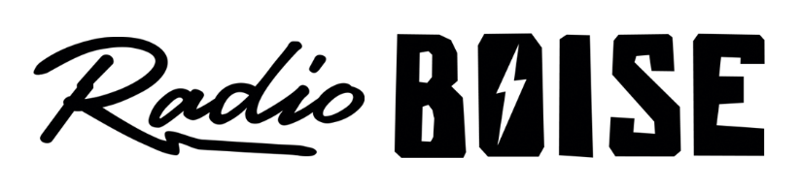
--AGENDA—

Radio Boise Board of Directors’ Meeting
Thursday, October 24, 2019, 6:00PM – Alaska Center, 2nd Floor Conference Room 1020 W Main Street, Boise, ID 83702

Agenda and minutes posted online at:
http://radioboise.us/board-of-directors/agendas-and-meeting-notes/

- Meeting Minutes (1 min) (Foster)
- Financial Update (10 mins) (Nystrom)
- Budgeting (15 mins) (Evett)
- GM Update (15 mins) (Evett)
- Board Development Committee Update (5 mins) (Foster)
- 2020 Officers (5 mins) (Foster)
- Strategic Planning: 3-year SMART goal presentations (20 mins) (All)
- Public Comment (5 mins)

Upcoming Board Events
- Next Board Meeting: _____________________________________________

