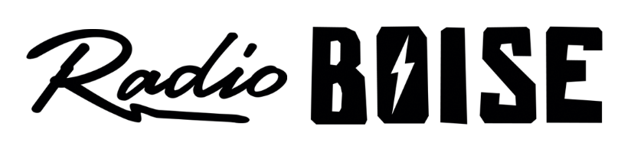
--Minutes--
Radio Boise Board of Directors (BoD) Meeting
Thursday, September 26, 2019 - - 6:00 - 7:40PM
Alaska Building – 2nd Floor Conference Room - 1020 Main St, Boise ID

BoD Members (11): Kristen Cheyney (Chair), Chelle Nystrom (Treasurer), James Lineberger (Secretary), Dave Foster (Immediate Past Chair), Alex Davis, Daniel Felkins, Daniel Glynn, Matt Hicks, Beth Markley, Jason Pretty Boy and Francisco Salinas.

BoD Members In Attendance (7): Cheyney, Nystrom, Felkins, Foster, Glynn, Hicks, Pretty Boy, and Jessica Evett (General Manager).

BoD Members Unable to Attend (4) : Lineberger, Davis, Markley, and Salinas

Staff: None
Visitors: None

Agenda and minutes are posted online at:
http://radioboise.us/board-of-directors/agendas-and-meeting-notes/

Convene: Cheyney called the meeting to order at 6:05pm, with quorum declared. There were no visitors to introduce.
Minutes: A motion to approve the minutes of the August board meeting held on August 11, 2019 board minutes was made by Foster, seconded by Hicks. The motion passed unanimously.
Financial Update: Nystrom presented August financials. Discussion on event revenue being lower than budgeted and expecting to see savings on Practice New Year’s Eve venue costs. Noted delay on grant funding. Discussion on how workshop instructor expenses were recorded. Reviewed balances and discussed how to improve AR. A motion was made by Cheyney, seconded by Glynn, to accept the financial report for the month of August, 2019. The motion passed unanimously.
GM Update: Evett presented a general manager update (previously posted on Slack) and answered questions. Food for thought discussion on how to expand public affairs programming. Discussed car raffle deficit at this point. Noted need to sell more tickets. Also discussed donations for Practice New Year’s Eve auction.
Space Expansion: Evett presented benefits of the expanded Radio Boise studio space and positive results from the effort to gauge interest from donors. Discussion on costs and potential revenue impact. Glynn moved to proceed forth with approving Evett to negotiate a lease for 8 months through April 2020 with a rental cap of $650 per month. The motion carried.
Board Development Committee Report: Discussed possible board candidates who would boost our mission regarding public affairs programming.
SMARTT Goals: Goals discussion was postponed for a future meeting.
Public Comment: None
Adjournment: The next meeting will be held on Thursday, October 24, 2019 at 6PM. There being no further business, Cheyney adjourned the meeting at 7:40 PM.

