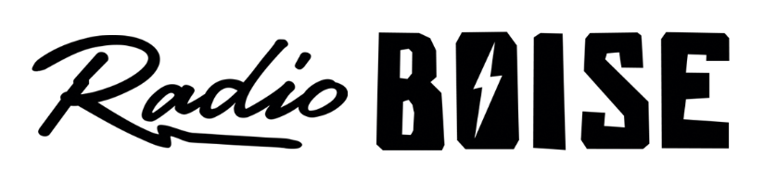
--Minutes--
Radio Boise Board of Directors (BoD) Meeting
Thursday, August 22, 2019 - - 6-7:30PM
Alaska Building – Garden Level (station lobby) - 1020 Main St, Boise ID

BoD Members (11): Kristen Cheyney (Chair), Chelle Nystrom (Treasurer), James Lineberger (Secretary), Dave Foster (Immediate Past Chair), Alex Davis, Daniel Felkins, Daniel Glynn, Matt Hicks, Beth Markley, Jason Pretty Boy and Francisco Salinas.

BoD Members In Attendance (7): Cheyney, Lineberger, Nystrom, Felkins, Foster, Glynn, Hicks, and Jessica Evett (General Manager).

BoD Members Unable to Attend (4) : Davis, Markley, Pretty Boy, and Salinas.

Staff: None
Visitors: None

Agenda and minutes are posted online at:
http://radioboise.us/board-of-directors/agendas-and-meeting-notes/

Convene: Cheyney called the meeting to order at 6:11pm, with quorum declared. There were no visitors to introduce.
Minutes: A motion to approve the minutes of the July board meeting held on August 1, 2019 board minutes was made by Foster, seconded by Cheyney. The motion passed.
Financial Update: Nystrom proposed acceptance of the March, April, May, June and July financial statements. A motion was made by Lineberger, seconded by Cheyney, to accept the financial report for the months of March, April and May, 2019. After some discussion, the motion passed unanimously. A motion was made by Lineberger, seconded by Cheyney, to accept the financial report for the months of June and July, 2019. After some discussion, the motion passed unanimously. The Blues Cruise was not managed particularly well and underperformed financially. The car raffle is significantly underperforming, with very low ticket sales to date.
GM Update: Evett presented a general manager update (previously posted on Slack) and answered questions.

SMARTT Goals: There are five (5) goal areas. Two (2) board members were assigned to develop SMART goals in each area. Preliminary goal areas with assignments:
- Staff goals: Foster & Lineberger
- Board goals: Davis, Cheyney & Salinas
- Operations goals: Markley & Evett
- Facilities & equipment: Pretty Boy & Felkins
- Financials: Nystrom, Glynn & Hicks
Due to a lack of remaining time, Lineberger made a motion, seconded by Cheyney, to table the presentation of SMARTT goals until the September board meeting.
Car Raffle: Evett distributed 25 raffle tickets and ticket logs to each board member present at the meeting. Each board member is expected to sell a minimum of 5 tickets per month through December (25 total).
Public Comment: None
Adjournment: The next meeting will be held on Thursday, September 26, 2019 at 6PM. There being no further business, Cheyney adjourned the meeting at 7:40PM.

