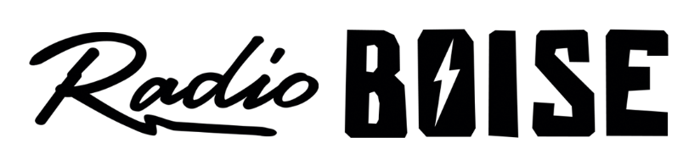
--Minutes--
Radio Boise Board of Directors (BoD) Meeting
Thursday, August 1, 2019 - - 6-7:30PM
Alaska Building – Garden Level (station lobby) - 1020 Main St, Boise ID

BoD Members (11): Kristen Cheyney (Chair), Chelle Nystrom (Treasurer), James Lineberger (Secretary), Dave Foster (Immediate Past Chair), Alex Davis, Daniel Felkins, Daniel Glynn, Matt Hicks, Beth Markley, Jason Pretty Boy and Francisco Salinas.

BoD Members In Attendance (7): Cheyney, Lineberger, Felkins, Davis, Markley, Pretty Boy, Foster and Jessica Evett (General Manager).

BoD Members Unable to Attend (4) : Nystrom, Glynn, Hicks and Salinas.

Staff: None
Visitors: None

Agenda and minutes are posted online at:
http://radioboise.us/board-of-directors/agendas-and-meeting-notes/

Convene: Cheyney called the meeting to order at 6:20pm, with quorum declared. There were no visitors to introduce.
Minutes: A motion to approve the May 24 2019 board minutes was made by Foster, seconded by Davis. The motion passed.
GM Update: Evett provided a facility update, including the potential for expanding into adjacent space recently vacated on the garden level of the Alaska Building. It offers sound-proofed production space. Additional rent is $650/month, with the thought to have it covered by targeted fund raising. Some limited tenant improvements may be needed, however, the space is necessary to sustain the podcasting initiative/vision. After discussion, a motion was made by Lineberger, seconded by Pretty Boy, to delegate authority to Evett pursue a non-binding letter of agreement (LOA) with the landlord to enable time to develop a plan for use and funding of the additional space. The motion passed with 6 in favor and 1 abstention.
Financial Update: Cheyney noted that the board has not received reconciled financial statements since March and urgently requires them to perform its fiduciary responsibility.
Strategic Planning Retreat: Cheyney led a review of the outcomes and next steps from the retreat (see notes previously distributed). The intent of the retreat was to develop a set of SMART, 3-year goals. There are five (5) goal areas. Two (2) board members will be assigned to develop SMART goals in each area.
Preliminary goal areas with assignments:
- Staff goals: Foster & Lineberger
- Board goals: Davis, Cheyney & Salinas
- Operations goals: Markley & Evett
- Facilities & equipment: Pretty Boy & Felkins
- Financials: Nystrom, Glynn & Hicks
Davis requested the SMART goal statements contain some context and background for each goal so that a layperson could readily comprehend it. Board members will present their SMART goals at the August board meeting, and are asked to publish their SMART goals to Slack at least 2 days prior to the meeting.
Public Comment: None
Adjournment: The next meeting will be held on Thursday, August 22nd at 6PM. There being no further business, Cheyney adjourned the meeting at 7:26PM.

