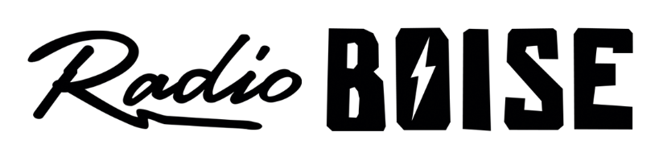
--AGENDA—

Radio Boise Board of Directors’ Meeting
Thursday, August 1, 2019, 6:00PM – Alaska Center, 2nd Floor Conference Room 1020 W Main Street, Boise, ID 83702

Agenda and minutes posted online at:
http://radioboise.us/board-of-directors/agendas-and-meeting-notes/

- Meeting Minutes (5 mins) (Lineberger)
- Strategic Planning: 3-year SMART goal development (45 mins) (Cheyney)
- GM Update (15 mins) (Evett)
- Financial Update (10 mins) (Chelle)
- Public Comment (5 mins)

Upcoming Board Events
- Strategic Planning Retreat, Saturday, June 22, 9:00AM – 5:00PM
- Next Board Meeting, Thursday, September 26, 6:00 – 7:30 pm, Alaska Center

Upcoming Radio Boise Events

