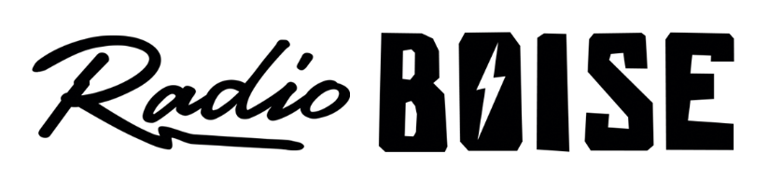
--Minutes--
Radio Boise Board of Directors (BoD) Meeting
Thursday, May 23, 2019 - - 6-7:30PM
Alaska Building – 2nd Floor Conference Room - 1020 Main St, Boise ID

BoD Members (11): Kristen Cheyney (Chair), Chelle Nystrom (Treasurer), James Lineberger (Secretary), Dave Foster (Immediate Past Chair), Alex Davis, Daniel Felkins, Daniel Glynn, Matt Hicks, Beth Markley, Jason Pretty Boy and Francisco Salinas.

BoD Members In Attendance (7): Cheyney, Nystrom, Lineberger, Glynn, Hicks, Markley, Pretty Boy and Jessica Evett (General Manager).

BoD Members Unable to Attend (4) : Davis, Felkins, Foster and Salinas.

Staff: Brian Allred
Visitors: Rina Kramer; Hunter Brodt;

Agenda and minutes are posted online at:
http://radioboise.us/board-of-directors/agendas-and-meeting-notes/

Convene: Cheyney called the meeting to order at 6:05pm, with quorum declared. Cheyney introduced the visitors.
Staff Update: Allred joined the board to provide an update on equipment, software and facilities (see attached “Equipment Needs Forecast”).
Minutes: A motion to approve the April 2019 board minutes was made by Glynn, seconded by Pretty Boy. The motion passed.
Strategic Planning Retreat: Saturday, June 22nd from 9AM – 5PM. Location is TBD. There will be some read-ahead/prep material for board members to review to be prepared. Outcomes will include high-level goals. The Executive Board will be meeting twice in June to prepare for the retreat.
Financial Update: Nystrom reviewed April financial documents, including the balance sheet and cash flow forecaster. The investment in the electric car without any corresponding raffle income is contributing to a bit of a cash flow shortfall in May (which should be the last lean month). Individual giving (thanks to corporate matches) is looking strong. Nystrom will post March and April financial statements for approval on Slack.
Fund Development Committee: Markley presented a brief report emphasizing the need for board members to call assigned HiFi society members.
Board Development Committee: Cheyney reported on the Boise Young Professionals event which she and Markley attended. Kramer and Brodt expressed interest at the event and joined the board meeting as visitors. Cheyney updated the board on two (2) other potential board candidates. Evett reported on one (1) potential board candidate.
HiFi Art: Evett reported that an artist has expressed interest in providing the art work for the 2020 HiFi society plaque.
GM Update: Evett provided an update (see attached). Evett noted that Boise State Public Radio extended their Spring fund drive which resulted in some overlap with Radio Boise. The goal was $60K which we very nearly met.
Public Comment: None
Adjournment: There being no further business, Cheyney adjourned the meeting at 7:10PM.

