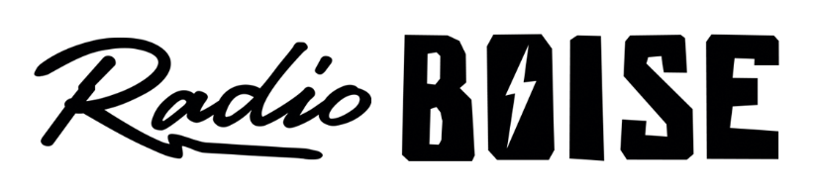
--AGENDA—

Radio Boise Board of Directors’ Meeting
Thursday, May 23, 2019, 6:00PM – Alaska Center, 2nd Floor Conference Room 1020 W Main Street, Boise, ID 83702

Agenda and minutes posted online at:
http://radioboise.us/board-of-directors/agendas-and-meeting-notes/

- Staff update (equipment, software, facilities) (10 mins) (Allred)
- Meeting Minutes (5 mins) (Lineberger)
- Strategic Planning (5 mins) (Cheyney)
- GM Update (15 mins) (Evett)
- Financial Update (10 mins) (Chelle)
- Fund Development Committee (5 mins) (Markley)
- Board Development Committee (5 mins) (Cheyney)
- Hi-FI Art and contact list spreadsheet (5 mins) (Evett/Cheyney)
- Public Comment (5 mins)

Upcoming Board Events
- Strategic Planning Retreat, Saturday, June 22, 9:00AM – 5:00PM
- Next Board Meeting, Thursday, July 25, 6:00 – 7:30 pm, Alaska Center

Upcoming Radio Boise Events
- HiFi Society Event – Wednesday, June 5th (Joshy Soul)
- Downtown Boise Father’s Day Car Show Sunday, June 16th
- Blues Cruise (McCall) Sunday, June 23rd
- HiFi Society Event – Tuesday, June 25th (Alejandro Escovedo)

