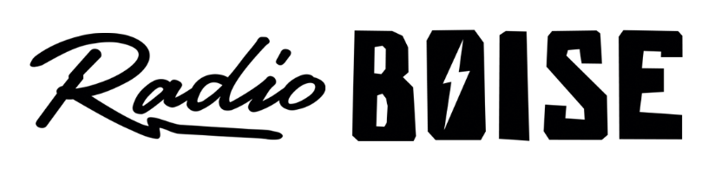
--Minutes--
Radio Boise Board of Directors (BoD) Meeting
Thursday, April 25, 2019 - - 6-7:30PM
Alaska Building – 2nd Floor Conference Room - 1020 Main St, Boise ID

BoD Members (11): Kristen Cheyney (Chair), Chelle Nystrom (Treasurer), James Lineberger (Secretary), Dave Foster (Immediate Past Chair), Alex Davis, Daniel Felkins, Daniel Glynn, Matt Hicks, Beth Markley, Jason Pretty Boy and Francisco Salinas.

BoD Members In Attendance (8): Cheyney, Nystrom, Lineberger, Davis, Flynn, Hicks, Markley and Pretty Boy and Jessica Evett (General Manager).

BoD Members Unable to Attend (3) : Foster, Felkins and Salinas.

Staff: None
Visitors: None

Agenda and minutes are posted online at:
http://radioboise.us/board-of-directors/agendas-and-meeting-notes/

Convene: Meeting called to order at 6:10pm, with quorum declared.
Minutes: A motion to approve the March 2019 board minutes was made by Glynn, seconded by Pretty Boy. The motion passed.
Slack App Training: Cheyney led a training session for the Slack App.
Strategic Planning: Cheyney led a discussion regarding the upcoming strategic planning session scheduled for Saturday, June 22nd (location TBD) from 9AM – 5PM. Cheyney asked the group to review material she will distribute in preparation for the retreat. There will be no BoD meeting in June.
General Manager/Radiothon Update: Evett led a discussion regarding staff sustainability and workload, including a proposal to split the responsibilities for event management and for the Controller role. A summary was distributed and discussed at length. Evett will model the proposal into the budget, discuss details with the Human Resource Committee and present a detailed proposal to the BoD via Slack.
Financial Update: Nystrom presented a brief update since April financial statements are not yet finalized. Statements will be provided to the board once available.
Fund Development: Markley reported there was no committee meeting this month. She discussed the Hi Fi Society spreadsheet. Existing members need to receive artwork from last year. There are a number of contributors who are close to being Hi Fi Society members, with a number of opportunities for giving going on now (Radiothon) and in the near future (Idaho Gives). Board members will be responsible for a number of Hi Fi Society members on the spreadsheet and can either select individuals on the spreadsheet or be assigned names to contact twice a year. Pretty Boy shared information regarding a Hi Fi Society Premium offering with the Newport Jazz Festival.
Electric Car Raffle: Evett reported that she has secured a vehicle (Fiat 500e). It will be wrapped and available for the Father’s Day Car Show. In the works are “Electric Car Tiny Concerts” event to promote a fun way to publicize the raffle.
Public Comment: None
Adjournment: There being no further business, Cheyney adjourned the meeting at 7:22PM.

