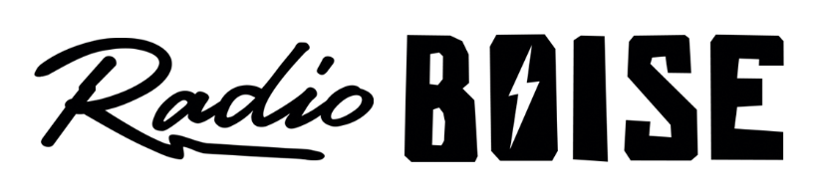
--AGENDA—

Radio Boise Board of Directors’ Meeting
Thursday, April 25, 2019, 6:00PM – Alaska Center, 2nd Floor Conference Room 1020 W Main Street, Boise, ID 83702

Agenda and minutes posted online at:
http://radioboise.us/board-of-directors/agendas-and-meeting-notes/

- Meeting Minutes (5 mins) (Lineberger)
- Slack training (5 mins) (Cheyney/Evett)
- Strategic Planning (10 mins) (Cheyney)
- GM/Radiothon Update (15 mins) (Evett)
- Financial Update (5 mins) (Chelle)
- Fund Development Committee (5 mins) (Markley)
- Hi-FI Art and contact list spreadsheet (15 mins) (Evett/Cheyney)
- Public Comment (5 mins)

Upcoming Board Events
- Next Board Meeting, Thursday, May 23, 6:00 – 7:30 pm, Alaska Center
- Strategic Planning Retreat, Saturday, June 22, 9:00AM – 3:00PM

Upcoming Radio Boise Events
- Idaho Gives at RecEX May 2nd
- Downtown Boise Father’s Day Car Show Sunday, June 16th
- Blues Cruise (McCall) Sunday, June 23rd
- https://radioboise.org/our-events/

