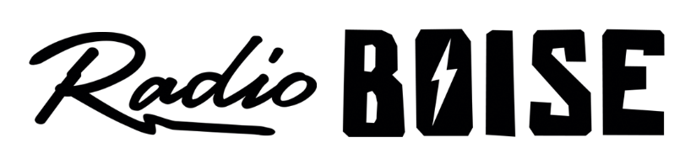
--AGENDA—

Radio Boise Board of Directors’ Meeting
Thursday, February,21 2019, 6:00PM – Alaska Center, 2nd Floor Conference Room 1020 W Main Street, Boise, ID 83702

Agenda and minutes posted online at:
http://radioboise.us/board-of-directors/agendas-and-meeting-notes/

- Owyhee Ridge update (10 minutes) (Evett)
- Meeting Minutes (5 minutes) (Lineberger)
- GM Update (15 minutes) (Evett)
- Board Development 2 minutes (Foster)
- Financial Update (20 minutes) (Evett)
- Fund Development Committee (10 Minutes) (Markley)
- Public Comment (5 minutes)

Upcoming Board Events
- Next Board Meeting, Thursday, March 28, 6:00 – 7:30 pm, Alaska Center

Upcoming Radio Boise Events
- TreeFort March 20-24
- RadioRace Broadcast TBD

