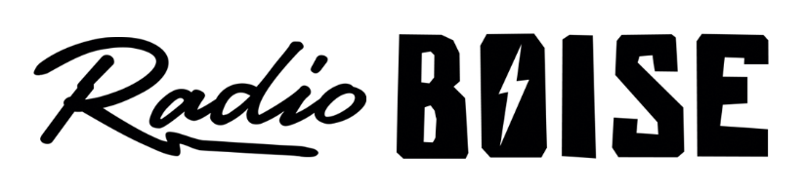
Radio Boise Board of Directors’ Meeting Minutes

Thursday, January 17, 2019 – Alaska Building

Cheney called the meeting to order at 6:05PM. Present were Foster, Felkins, Pretty Boy, Evett, Glynn, Nystrom, Markley, Davis. Quorum was declared.

Minutes A motion was made by Cheney, seconded by Foster, to approve the minutes of the meeting of November, 15 2018. With no objections, the motion passed.

GM Update Evett provided a verbal GM update. Antenna repaired. Discussed the amplifier issues related to causing recent outage. Explored backup plans.
Reviewed underwriting and sponsorship 2019 plans related to Radio Boise Tuesday and car raffle. Starting negotiation for the car to raffle. Also planning raffle ticket sales calendar.
Podcasting workshop scheduled for February. Patagonia media grant awarded to Radio Boise for citizen podcasting on the environment.
Destination Caldwell is coordinating events with Radio Boise.
Possible TedX partnership to promote diversity of audience.

Board Development Update Reviewed list of possible candidates for the board.

Antenna Update Michael Brown discovered in November 2018 that our antenna was not rotated correctly. We are still having reflective power and VSWR issues. Still communicating with landlord and insurance company to address a remedy.

Budget Discussion Reviewed comparison between projected 2018 actuals and 2019 budget. Pursuing sponsorships to ensure funding for the car. Planning for equipment maintenance and upgrades. Pretty boy moved to approve the budget, Glynn seconded, the motion carried with one member abstaining.

Public Comment No comments.

The meeting adjourned at 7:45PM

