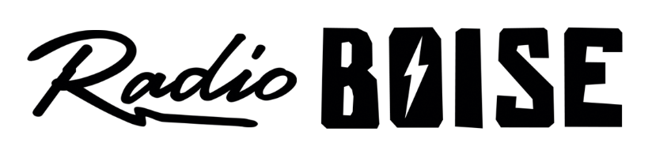
--AGENDA—

Radio Boise Board of Directors’ Meeting
Thursday, January,17 2019, 6:00PM – Alaska Center, 2nd Floor Conference Room 1020 W Main Street, Boise, ID 83702

Agenda and minutes posted online at:
http://radioboise.us/board-of-directors/agendas-and-meeting-notes/

- Antenna update (20 minutes) (Evett)
- Meeting Minutes (5 minutes) (Cheyney)
- GM Update (15 minutes) (Evett)
- Board Development 2 minutes (Cheyney)
- Budget / Financial Update (20 minutes) (Nystrom)
- Public Comment (5 minutes)

Upcoming Board Events
- Next Board Meeting, Thursday, February 27, 6:00 – 7:30 pm, Alaska Center

Upcoming Radio Boise Events
- Radio Boise New Volunteer Orientation Monday, February 11, 5:30-7:00pm
- Radio Race Saturday and Sunday February 16/17

