Radio Boise Board of Directors’ Meeting Minutes

Thursday, November 15, 2018 – Alaska Building

Dave Foster called the meeting to order at 6:05PM. Present were Dave Foster, Daniel Felkins, Beth Markley, Jason Pretty Boy, Jessica Evett, James Lineberger and Chelle Nystrom (via telephone). Quorum was declared.

A motion was made by Markley, seconded by Lineberger, to approve the minutes of the meeting of October 11, 2018. The motion passed without objection.

Transmitter trip/antenna repair report. Brian Allred (Operation Manager) presented a trip report related to the repair of the antenna on between October 28th – November 14th (attached to these minutes). The repair is 80% complete. There is some follow up needed regarding the insurance claim.

GM Update. Evett provided a verbal GM update. Snake River Conservation Area is providing $2K for a 30-minute piece. Idaho Humanities Council is highlighting the station in their next newsletter. Greater Sum Foundation has accepted the station as a finalist for grant funding. The station is one of the 11 finalists for Biz Lab (provides $15K if awarded). A Patagonia grant is also a possibility. Radiothon raised just over $58K – the most successful radiothon ever! Auction Frogs is underwritten for Practice NYE and recommends consideration of an online auction for two weeks. More car raffle tickets have been sold this year at this point compared to last year, though we will not meet the $40K target.

Elections. Foster facilitated the nomination and election of officers (per the Bylaws). He proposed a slate of officers: Cheyney (Chair), Foster (Vice Chair), Nystrom (Treasurer), Lineberger (Secretary). A motion was made by Pretty Boy, seconded by Markley, to accept the slate. The motion passed without objection.

Budget discussion. Evett led a discussion of the 2019 calendar year budget. To continue the car raffle, we need to find an underwriter prior to purchasing the vehicle. Radiothon targets remain conservative despite the success of the Fall 2018 radiothon. Cash flow has improved somewhat (due to grant funding, especially unrestricted grants). January – March represent the greatest cash flow challenges. Evett will distribute the preliminary budget for review (along with reconciled October financial statements), with the intent for approval by board members via e-mail.

Public comment. No comments.

The meeting adjourned at 7:05PM

Transmitter trip/antenna repair 10/27/2018
08:00 AM: Michael Brown, Rick Strack, myself and the 3 man tower crew from Idaho Tower Construction arrived at the transmitter site in the Owyhee Ridge.
08:30-10:00 AM: We switched to the backup antenna, powered down the other transmitters on site and the tower crew climbed the tower and lowered the remaining part of the antenna.
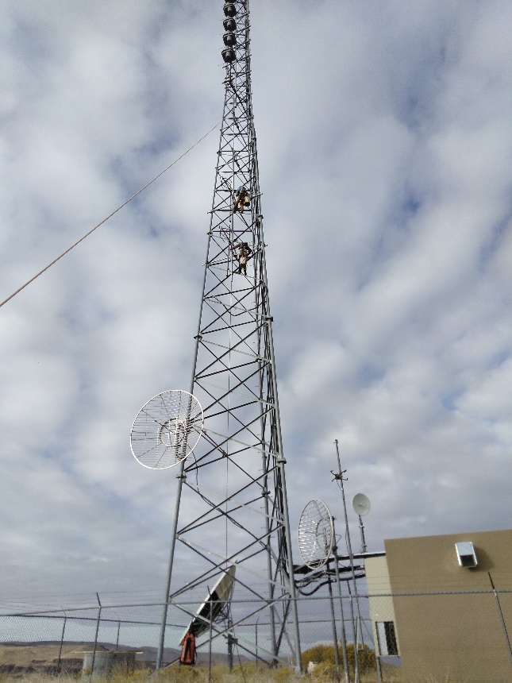
10:00 AM-noon: We thoroughly cleaned every part of the antenna assembly with 99% isopropyl alcohol and lint free cloths. We replaced every O-ring, bolt and connector bullets. The bays were disassembled, cleaned and put back in their original configuration.
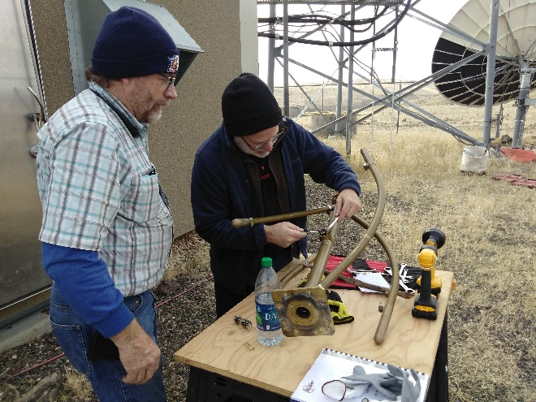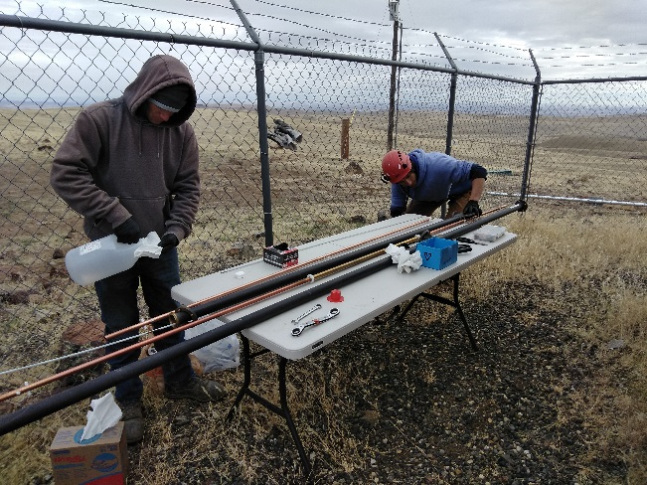

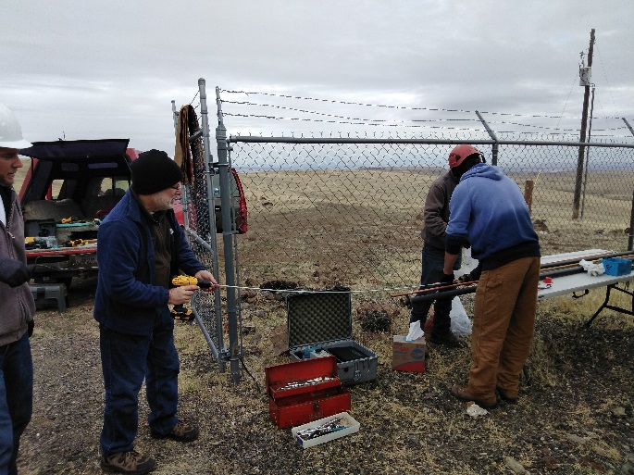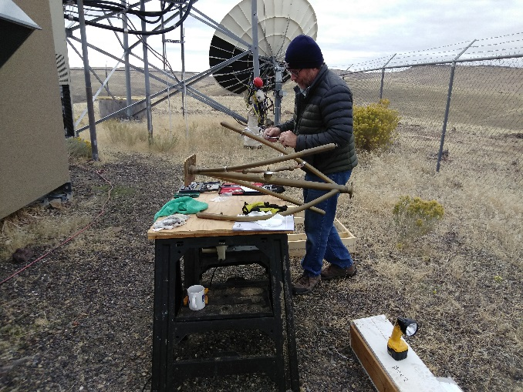
Noon-2:30 PM This time was spend putting the antenna back together. We started with mounting the inner conductor and outer pipe to the mounting brackets.
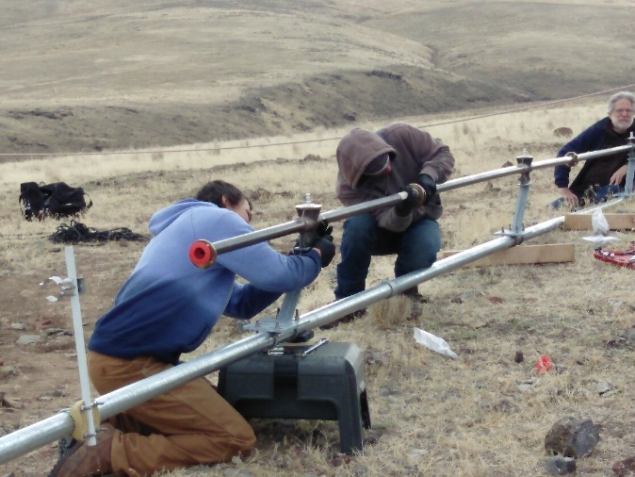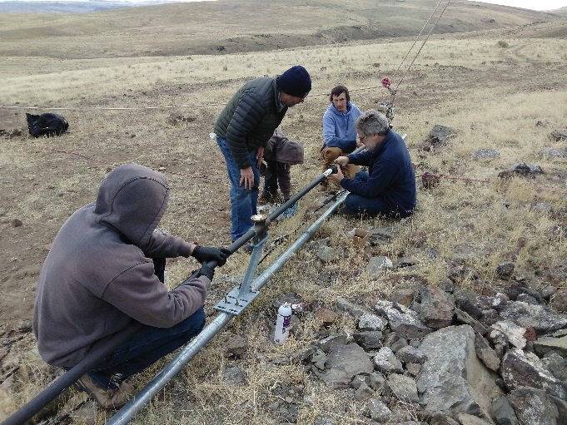
Next each antenna bay was installed onto a connecting bullet and O-ring and checked for leaks.
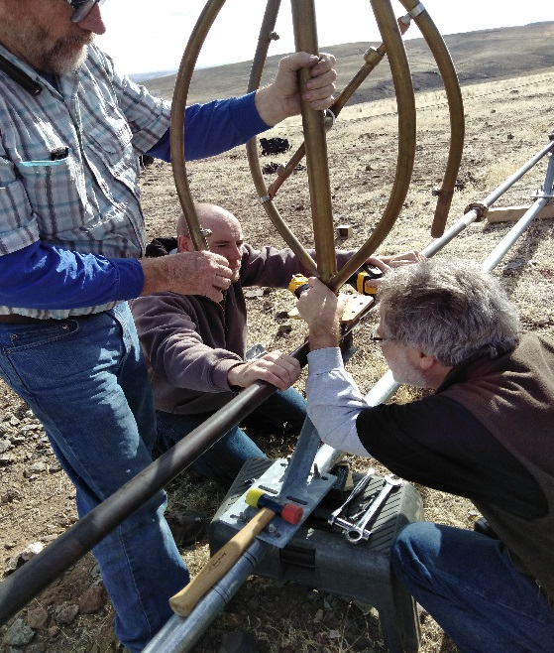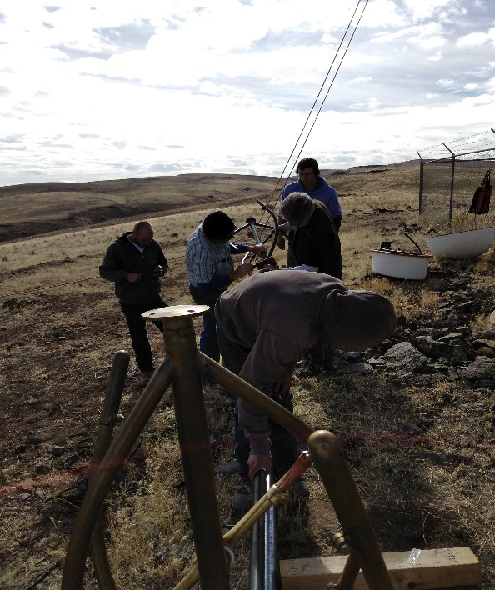
Finally, the radomes (weather shields) were installed. These are made of fiberglass and are extremely heavy. As we added more weight to the structure, two of us had to trade off and hold the antenna while the radomes were installed.
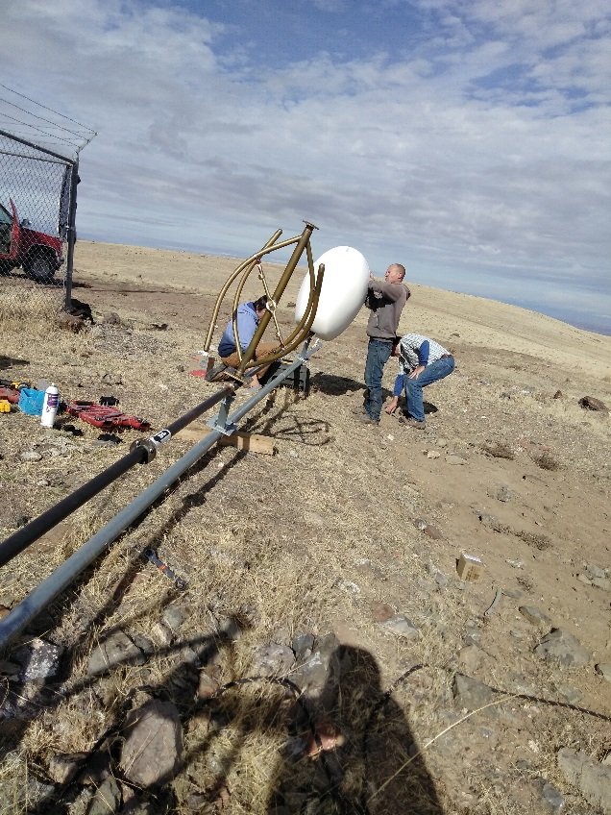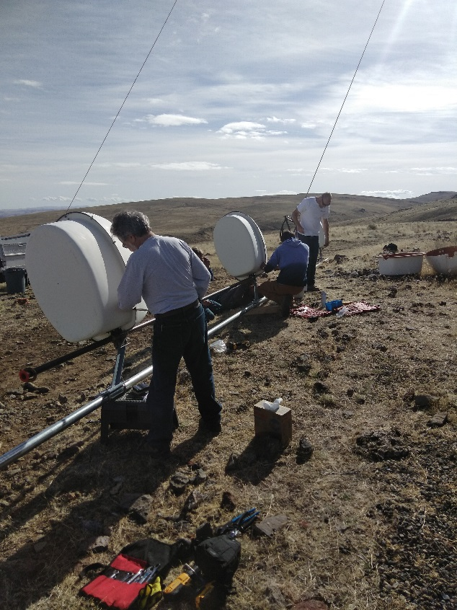
2:30-4:00 PM The antenna was raised back onto the tower. It was secured to the main mounting brackets on the tower structure.
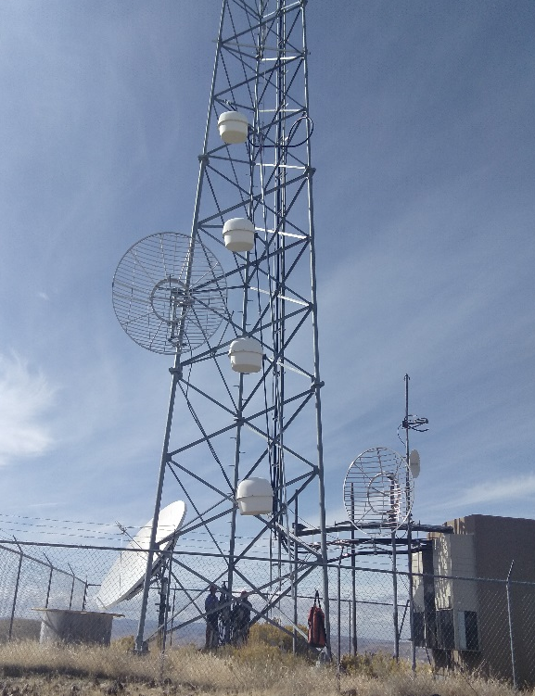
While the crew was still on the tower, we connected the pressure hose in the building to the nitrogen tank and ran it through the main feed line and antenna. This was done before any current was run through the antenna in order to remove any moisture in the line of main antenna. Nitrogen was run for about 45 minutes. We then reconnected the pressure hose to the desicant and re-pressurized the feed line.
4:00 PM-5:45 PM We disconnected the back up antenna and re-attached the main feedline. We used a spectrum analyzer to conduct testing on the antenna before powering the transmitter back up. It was at this time that Michael Brown anticipated that the reflected power and voltage standing wave ratio (vswr) would be in his words, “mediocre”.
***VSWR (Voltage Standing Wave Ratio) is basically how closely the input and output voltage match along a transmission line (from the transmitter generating the voltage through the feedline to the antenna, which acts as giant conductor, radiating that energy in the form of radio waves. In the case of our antenna, the transmitter generates a signal at 89.9 mHz. The bays on the antenna are tuned to radiate at that frequency.
“Such a mismatch is usually undesired and results in standing waves along the transmission line which magnifies transmission line losses (significant at higher frequencies and for longer cables). The SWR is a measure of the depth of those standing waves and is, therefore, a measure of the matching of the load to the transmission line. A matched load would result in an SWR of 1:1 implying no reflected wave. An infinite SWR represents complete reflection by a load unable to absorb electrical power, with all the incident power reflected back towards the source.”- https://en.wikipedia.org/wiki/Standing_wave_ratio
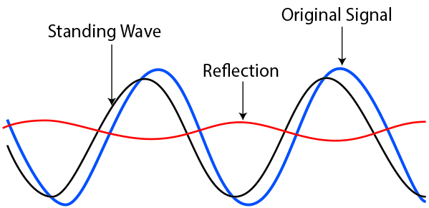
Conclusions: I would rate the project about 80% complete. Yes there are still some kinks that need to be worked out and some fine tuning that needs to be done on the antenna in order to correct this. We also did find some evidence of some carbon in the main feedline. Michael and Rick both recommended that it be replaced. They are going to price out that length of cable. The next steps will be to consult with Jampro to find out the best way to fine tune the antenna bays while still on the tower. The engineers think that one or more of the bays could be out of tune even by a millimeter, which would account for the elevated VSWR. If the current VSWR remains stable. Also, they will advise if we can keep power at current levels until we come out with a tower crew in the spring. As noted the VSWR of 1:27:1 is very mediocre and we do not want to maintain it for a long period of time.
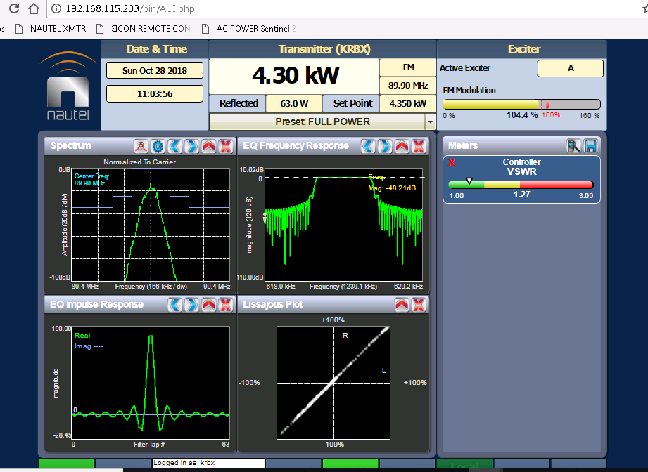

Trip with Michael Brown and tower crew 11/14/18
Update: We flew in Michael Brown, our design engineer, and performed additional testing on the feedline and antenna. The feedline tested out to have no issues, although due to the evidence of carbon we saw previously it is recommended that we replace the line. The testing eliminated an imminent failure and points towards one or more bays being slightly out of tune and possibly the mounting of the antenna bays needs to be redone. This means that we can conclude the project in the spring (probably May, weather permitting). The goal is to get the VSWR into an acceptable range of about 1.15:1. Please feel free to contact me directly with any questions or for clarification.
Brian Allred
Operations Manager
Radio Boise
208-477-9499
ballred@radioboise.org

