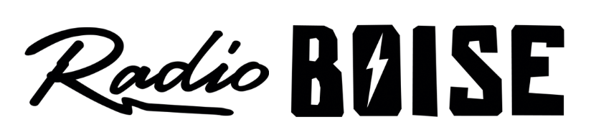
--AGENDA—

Radio Boise Board of Directors’ Meeting
Thursday, November 15, 2018, 6:00PM – Alaska Center, 2nd Floor Conference Room 1020 W Main Street, Boise, ID 83702

Agenda and minutes posted online at:
http://radioboise.us/board-of-directors/agendas-and-meeting-notes/

- Antenna update (5 minutes) (Allred)
- Meeting Minutes (5 minutes) (Foster)
- GM Update (10 minutes) (Evett)
- Car Raffle (5 minutes) (Evett)
- Election (5 minutes) (Foster)
- Budget / Financial Update (20 minutes) (Nystrom)
- Public Comment (5 minutes)

Upcoming Board Events
- Next Board Meeting, Thursday, January 17, 6:00 – 7:30 pm, Alaska Center

Upcoming Radio Boise Events
- Fall Radiothon Pick-Up Party, Thursday, November 15, 2018, 5 PM – 9 PM at Payette Brewing Co. 733 South Pioneer Street, Boise, Idaho 83702
- Radio Boise Tuesday: Ural Thomas & The Pain with Afrosonics, Tuesday, November 20, 2018 at Neurolux 111 N 11th St, Boise, Idaho 83702
- Practice New Year's Eve Party, Friday, December 7, 2018, at The Linen Building 1402 W Grove St, Boise, ID 83702

