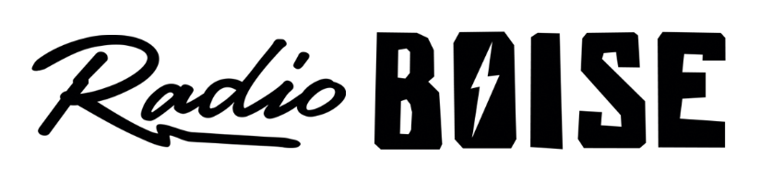
Radio Boise Board of Directors’ Meeting Minutes

Thursday, October 11, 2018 – Alaska Building

Dave Foster called the meeting to order at 6:15PM. Present were Dave Foster Alex Davis, Daniel Felkins, Beth Markley, Jason Pretty Boy, Kristen Cheyney, Jessica Evett, James Lineberger & Csea Leonard (guest). Quorum was declared.

A motion was made by Markley, seconded by Lineberger, to approve the minutes of the meeting of August 30, 2018. With no objections, the motion passed.

GM Update. Evett provided a GM update (see attached report).

Board Development Update. Cheyney presented information regarding prospective board members. Cheyney introduced Cesea Leonard who joined the meeting as a guest. Cheyney related that she has reviewed the online board member application, changing the board contact information. The group discussed criteria for board members. Cheyney asked board members to continue to seek potential candidates.

Budget discussion. Evett led a discussion of the proposed 2019 budget. The group spent substantial time discussing event timing and goals. The group discussed the potential for augmenting the current staff on a contract basis. The board will vote on the budget at its next meeting on November 15th.

Fund Development: The group acknowledged that the topic had somewhat been covered in the previous discussion.

Public comment. No comments.

The meeting adjourned at 7:30PM

