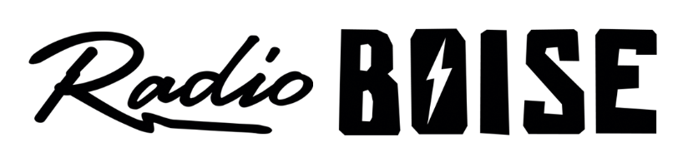
Radio Boise Board of Directors’ Meeting Minutes

Thursday, August 30, 2018 • Alaska Building

Call to order and roll call. Cheyney called the meeting to order at 6:05PM. Present were Evett, Cheyney, Markley, Nystrom, Felkins, Glynn, Pretty Boy and Foster. Quorum was declared.

Approval of minutes. Motion by Glynn, seconded by Felkins, to approve the minutes of the most recent meeting. The motion passed without objections.

GM Update. Evett provided a GM update. Discussion on antenna claim, underwriting, programming changes, Pretty Boy reported that the Radio Boise Community Advisory Board should be active by Jan 2019. Call for more volunteers. No action was taken by the board.

Board development. Cheyney reported on applicants and interview schedules.

Budget/financial update. Nystrom led a discussion regarding the financial statements and reports. She noted that car donations are looking good as well as underwriting. Collections can be improved by working on pay now options. Raffle going slower than expected. Discussed preliminary budget.

Fund development update. Evett reviewed car raffle events and promotions. Discussion on HiFi activities and events. High priority placed on matching gifts for Radiothon.

Public comment. No comments.

The meeting was adjourned at 7:30PM

